**K-Means Clustering**

**Assumptions:**

Max Iterations = 50

**Given Image Information**

Size – 220 * 200

Matric – 220 * 200 * 3

**Normalization (Optional)**

Dividing each pixel’s value by 255, to convert values into smaller ones.

**Compression Results**

**Compressed Image with K = 2**

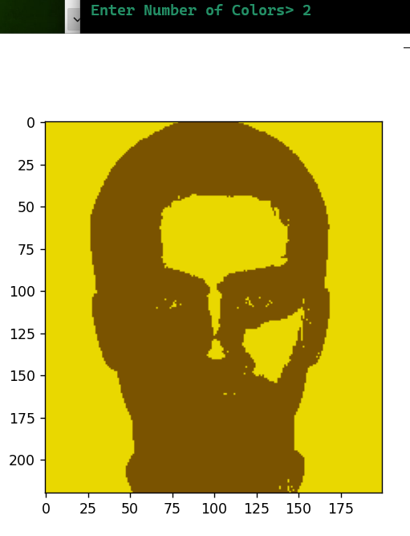

**Image Size:** 20 Kilo Bytes

**Comment:**

Since there are only 2 colors to represent pixels, a lot of contrast and information is lost from the image. It is almost impossible to see facial features.

**Compressed Image with K = 3**

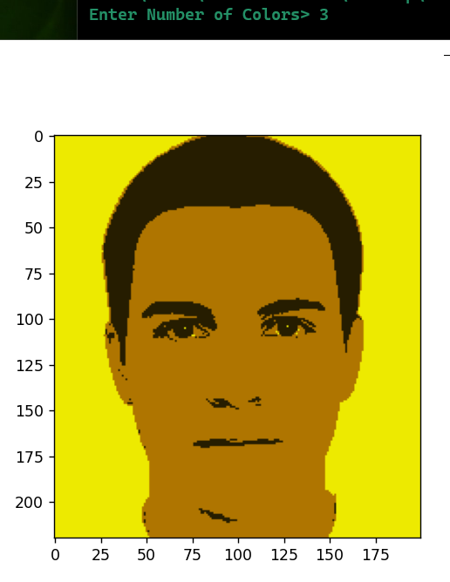

**Image Size:** 23 Kilo Bytes

**Comment:**

This image is much better than that of with k = 2. Here much more features are visible and we can get better information from the image. Nevertheless, the light, shadows, and texture is still lost in this compression.

**Compressed Image with K = 5**

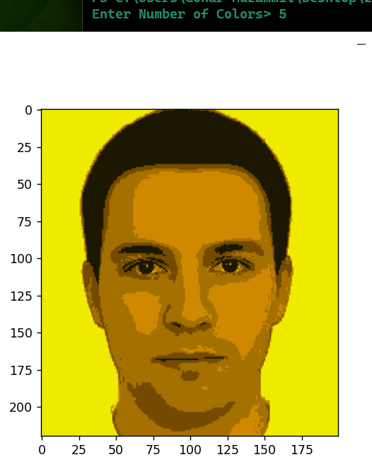

**Image Size:** 36 Kilo Bytes

**Comment:**

This compressed image comprises of better shadows, textures, light and contrast. Much of the facial features are visible. But still the image lost information about the complexion of the man.

**Compressed Image with K = 10**

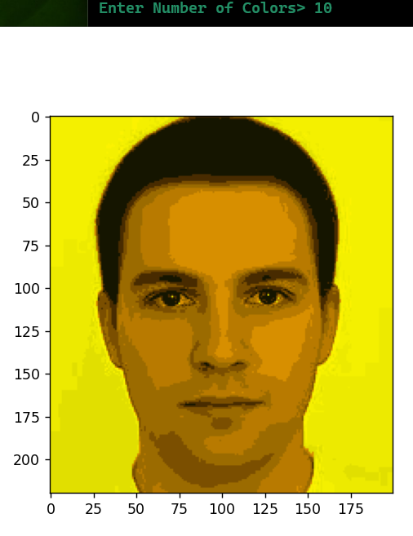

**Image Size:** 48 Kilo Bytes

**Comment:**

An overall better image with better colors for viewing textures, facial features, facial boundaries, contrast.

**Compressed Image with K = 15**

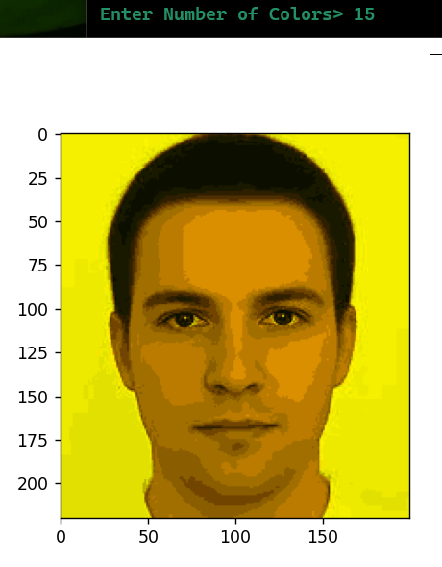

**Image Size:** 59 Kilo Bytes

**Comment:**

This image is a sweet spot for me as it shows a lot of information as compared to the previous ones. In fact, we can see the texture of the hair too in this image.

**Compressed Image with K = 20**

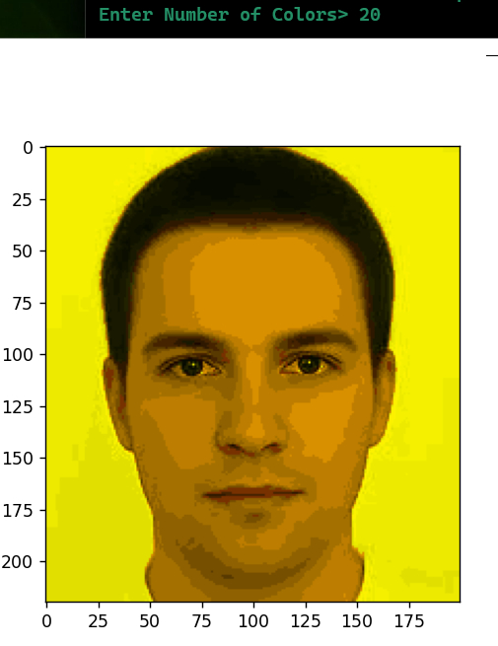

**Image Size:** 65 Kilo Bytes

**Comment:**

There isn’t much of a difference between this one and the previous one (compressed with k = 15) in terms of information. This image shows better complexion and shadows, in the areas such as chin, ears and eyes. Image presents better highlight and contrast.